Day 3 - Install and Run Express Setup
Verify `karabonode.co.za` in Entra first
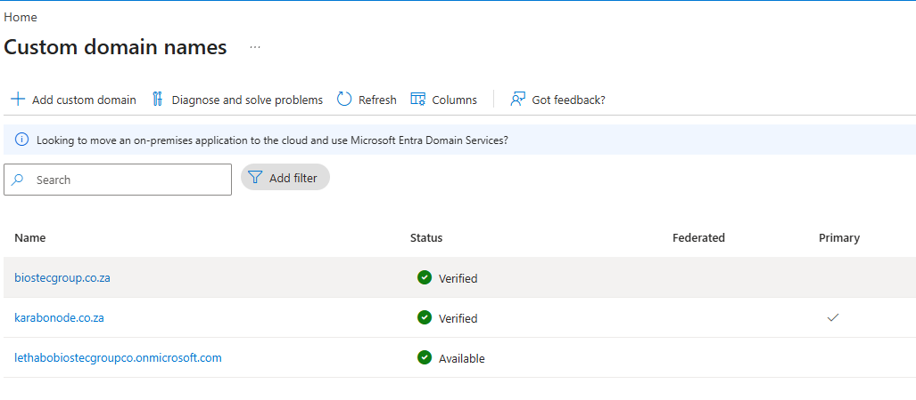
Run the installer
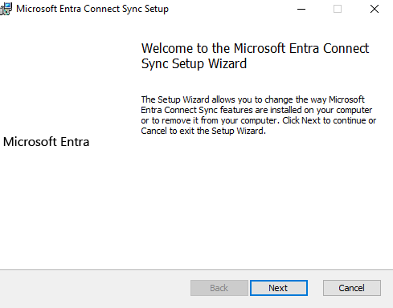
Choose Express Settings
Express is the right call for a single-forest, single-tenant setup like this one: it configures password hash synchronization, syncs all objects in the forest, and enables the default sync cycle automatically. (Custom settings exist for multi-forest environments, OU filtering, and alternative sign-in methods
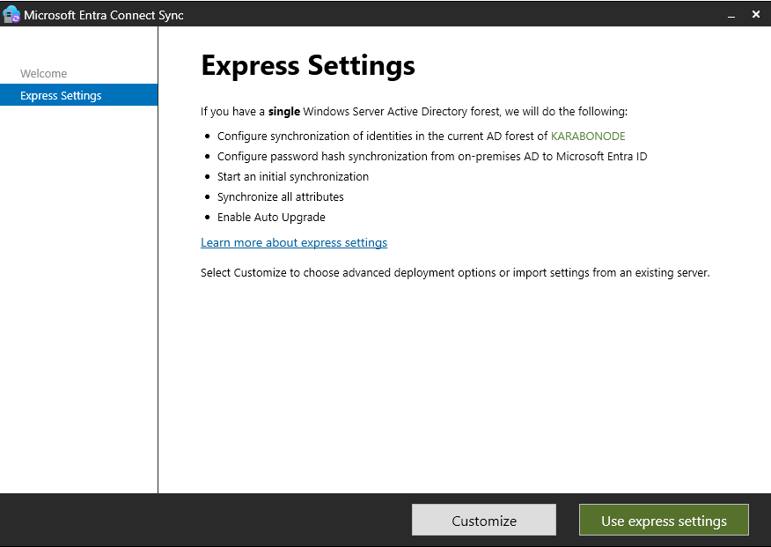
UPN suffix should now line up cleanly
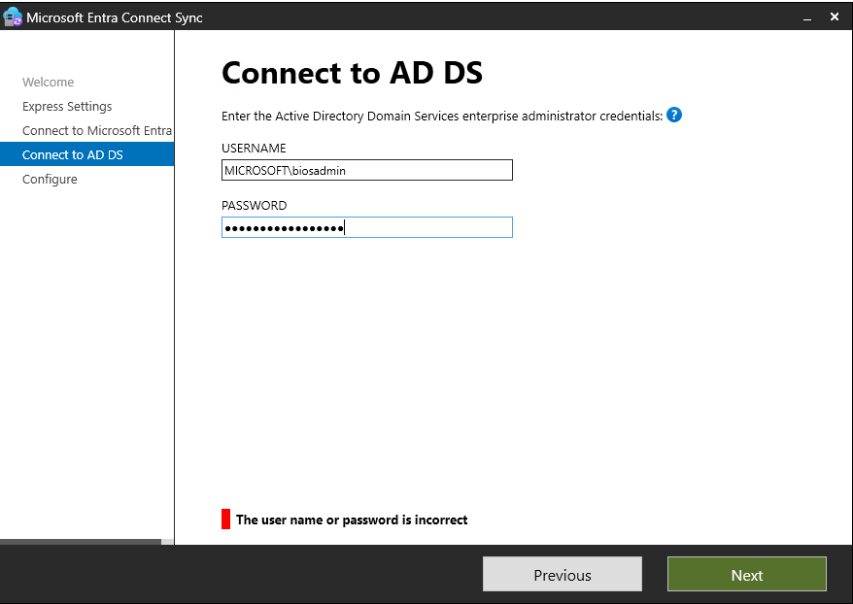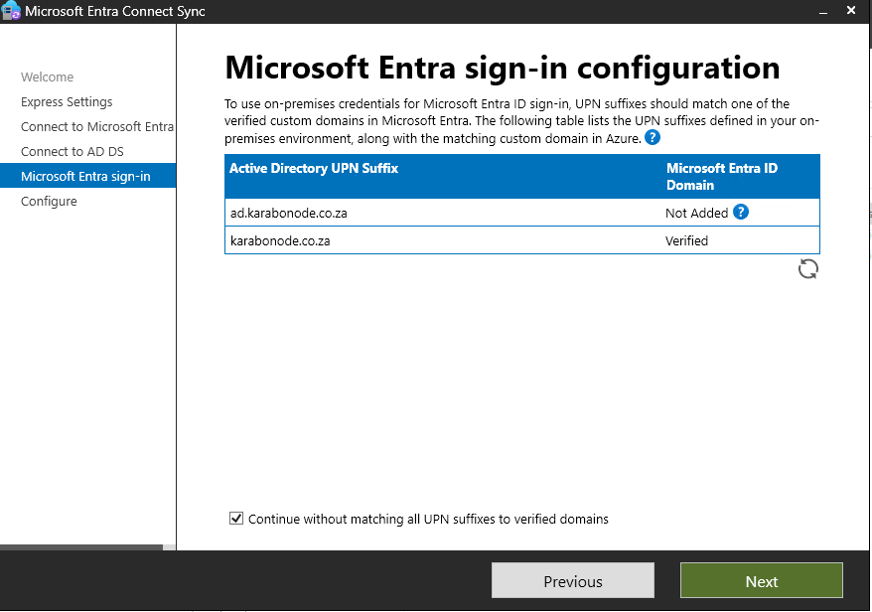
Click Install and let it complete the initial sync
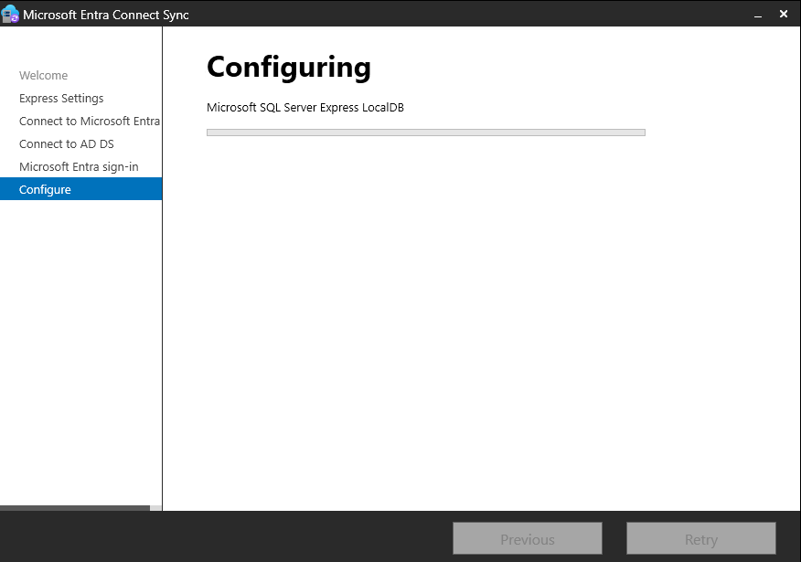

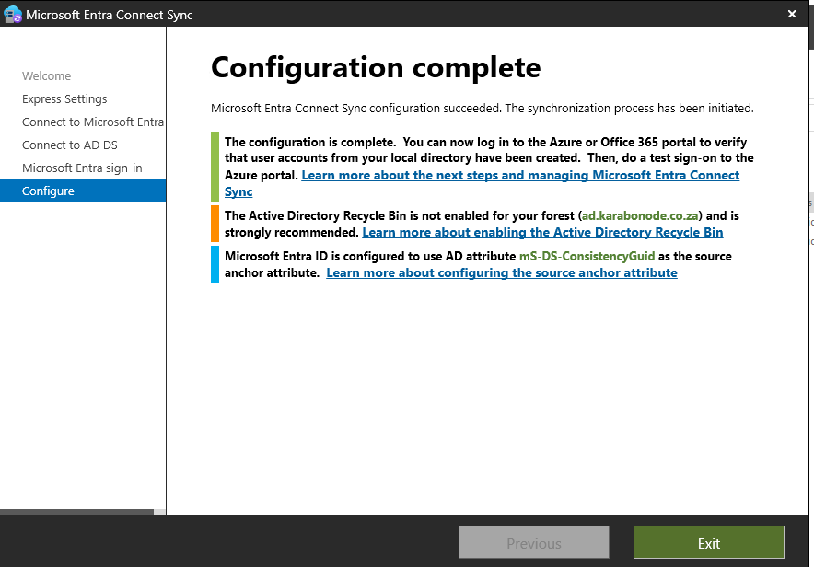 Why this matters
This is the single most direct skill match to the Azure & AD Specialist posting.
Skills covered
Entra Connect Sync installation, Express vs. Custom settings judgment, the dual-credential security model, UPN-suffix/verified-domain awareness for hybrid environments.

